Supplementary Material
Original Article
Global prevalence of cannabis and amphetamine/methamphetamine use among adolescents in 47 countries: a population-based study from WHO database

Yejun Son^{1,2} Seohyun Hong^{1,3} Yesol Yim^{1,2} Soeun Kim^{1,2} Hojae Lee^{1,4} Kyeongmin Lee^{1,4} Hyeon Jin Kim^{1,2} Hyesu Jo^{1,4} Jaeyu Park^{1,2} Jiyeon Oh^{1,3} Sooji Lee^{1,3} Hayeon Lee^{1,5} Christa J. Nehs^{6,7} Lee Smith⁸ Dong Keon Yon^{1,2,3,4,9} Jiseung Kang^{6,7,10,11}

Corresponding authors:
Dong Keon Yon, MD, PhD, FACAAI, FAAAAI
Department of Pediatrics, Kyung Hee University College of Medicine, 23 Kyungheedae–ro, Dongdaemun–gu, Seoul 02447, South Korea
Tel: +82–2–6935–2476
Fax: +82–504–478–0201
Email: yonkkang@gmail.com

Jiseung Kang, PhD
Department of Anesthesia, Critical Care and Pain Medicine, Massachusetts General Hospital, 149 13th Street, Room 4140, Charlestown, Boston, MA, USA
Division of Sleep Medicine, Harvard Medical School, Boston, MA, USA
Tel: +1-617-356-2742
E-mail: wltmd1006@gmail.com
Contents of supplementary appendix

Supplementary Material | Supplementary Material
Figure S1 | Prevalence of cannabis and amphetamine use by World Bank income classifications over time
Figure S2 | Prevalence of cannabis and amphetamine use by homicide rate levels over time
Figure S3 | Prevalence of cannabis and amphetamine use by sanitation service levels over time
Figure S4 | Prevalence of cannabis and amphetamine use by health expenditure levels over time
Table S1 | Baseline characteristics of the study
Table S2 | Prevalence of combined categories of cannabis use and amphetamine/methamphetamine
Table S3 | Prevalence of combined categories of drug initiation age

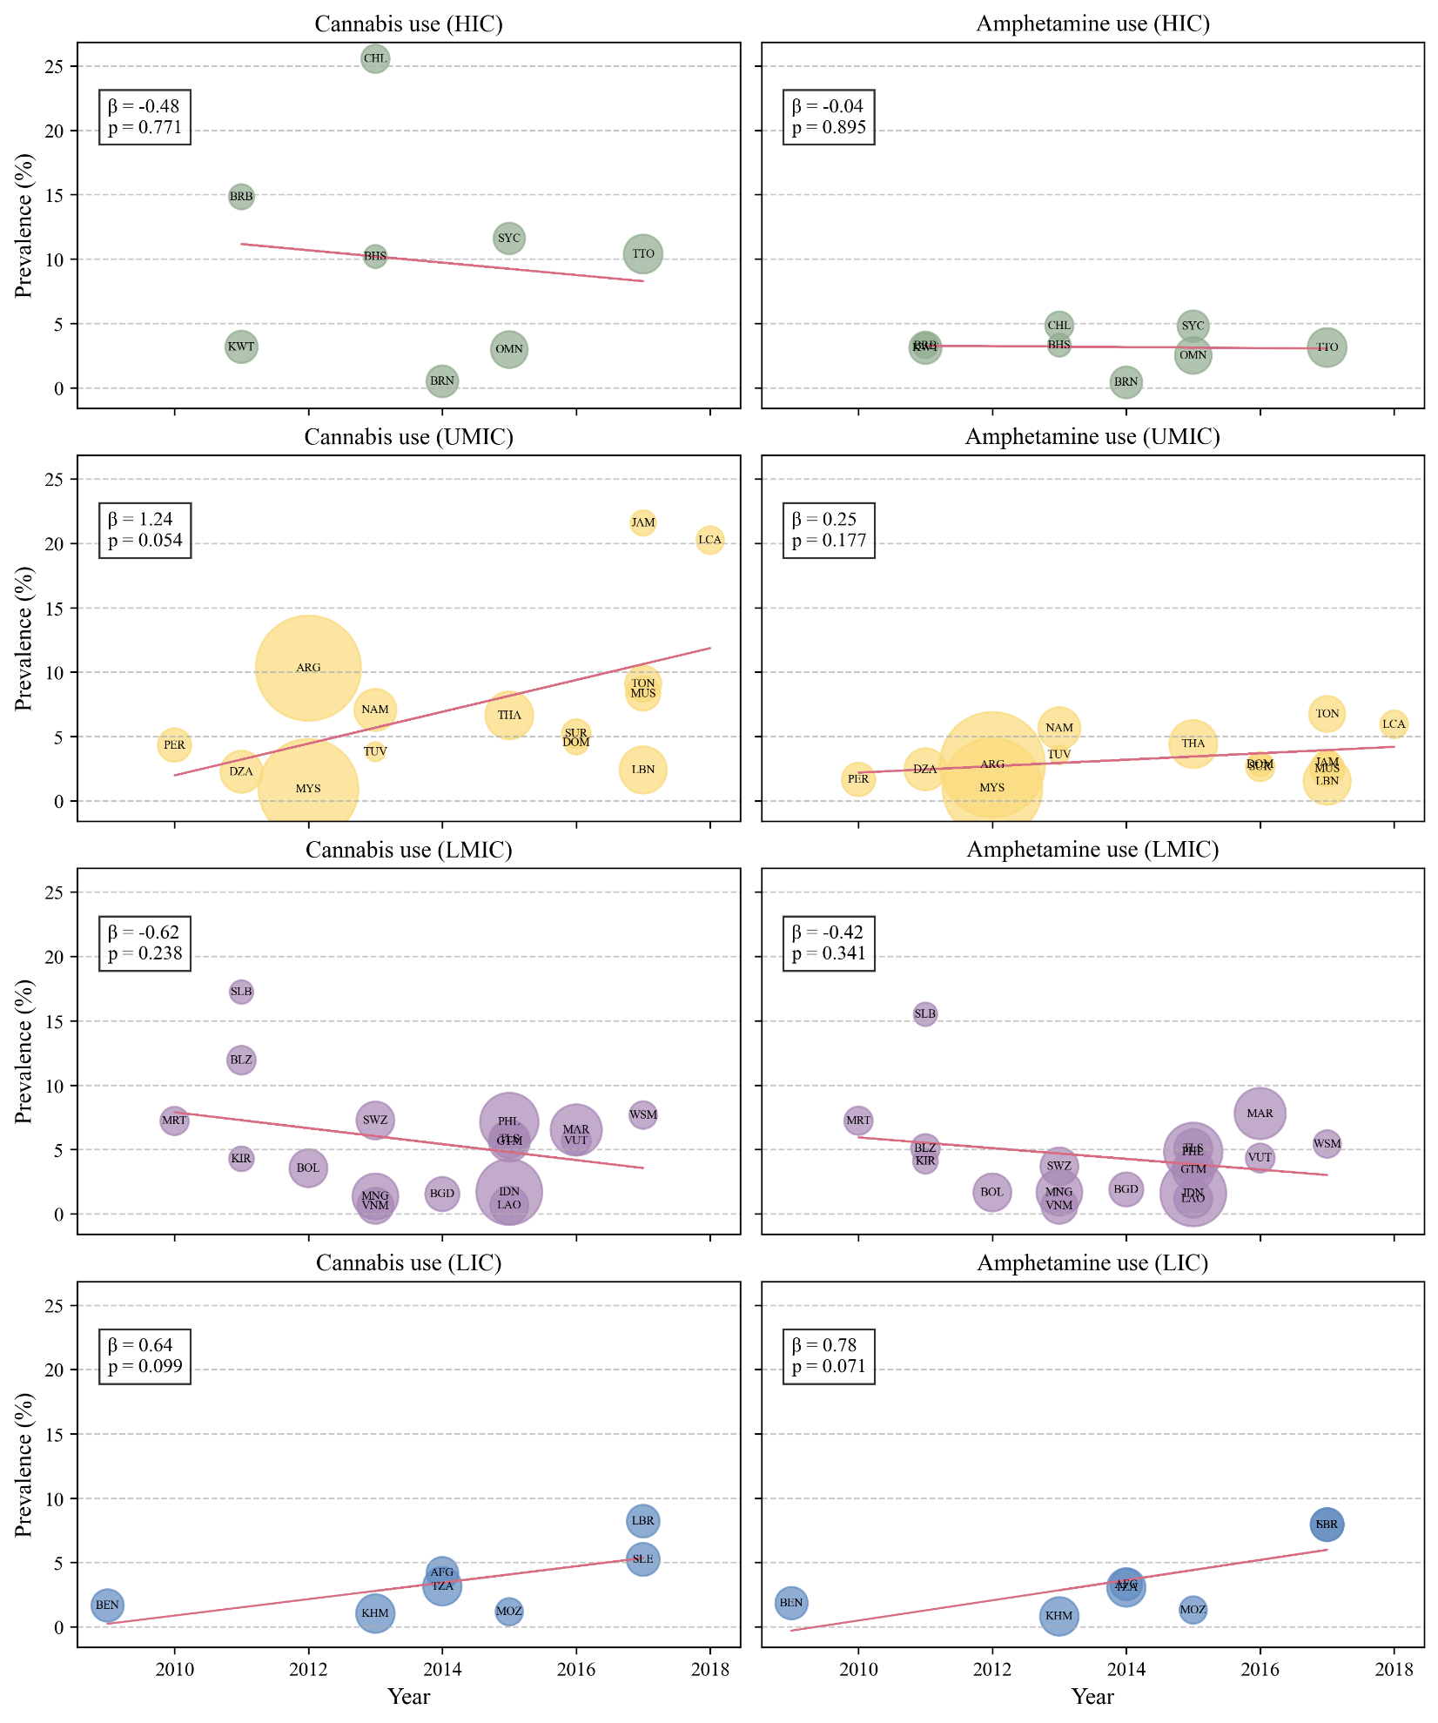
Figure S1. Prevalence of cannabis and amphetamine use by World Bank income classifications over time
Abbreviations: HIC, high-income countries; LIC, low-income countries; LMIC, lower-middle income countries; UMIC, upper-middle-income countries.

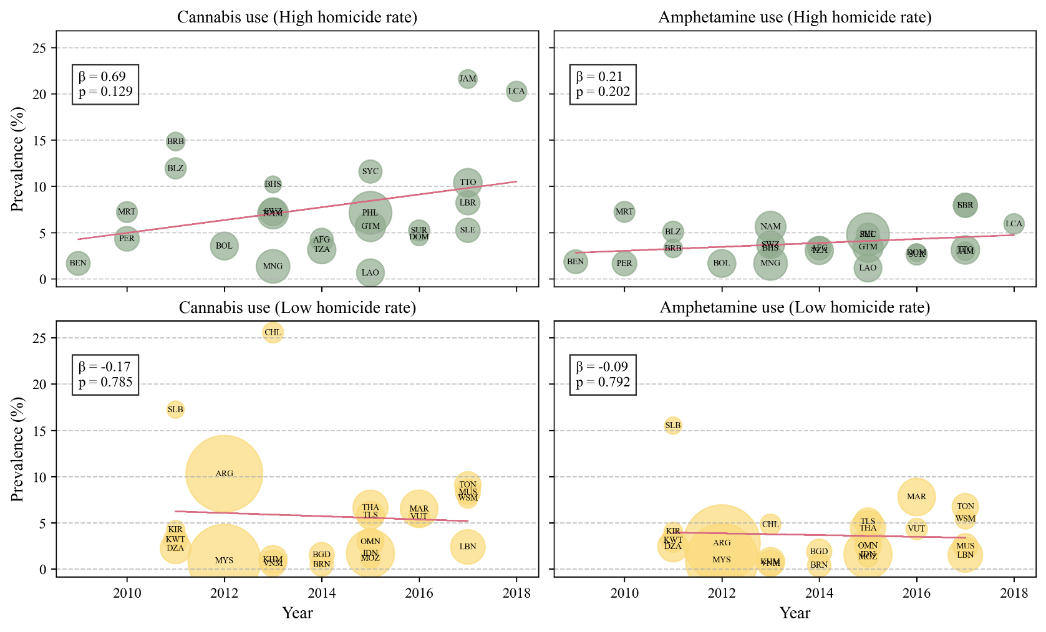
Figure S2. Prevalence of cannabis and amphetamine use by homicide rate levels over time

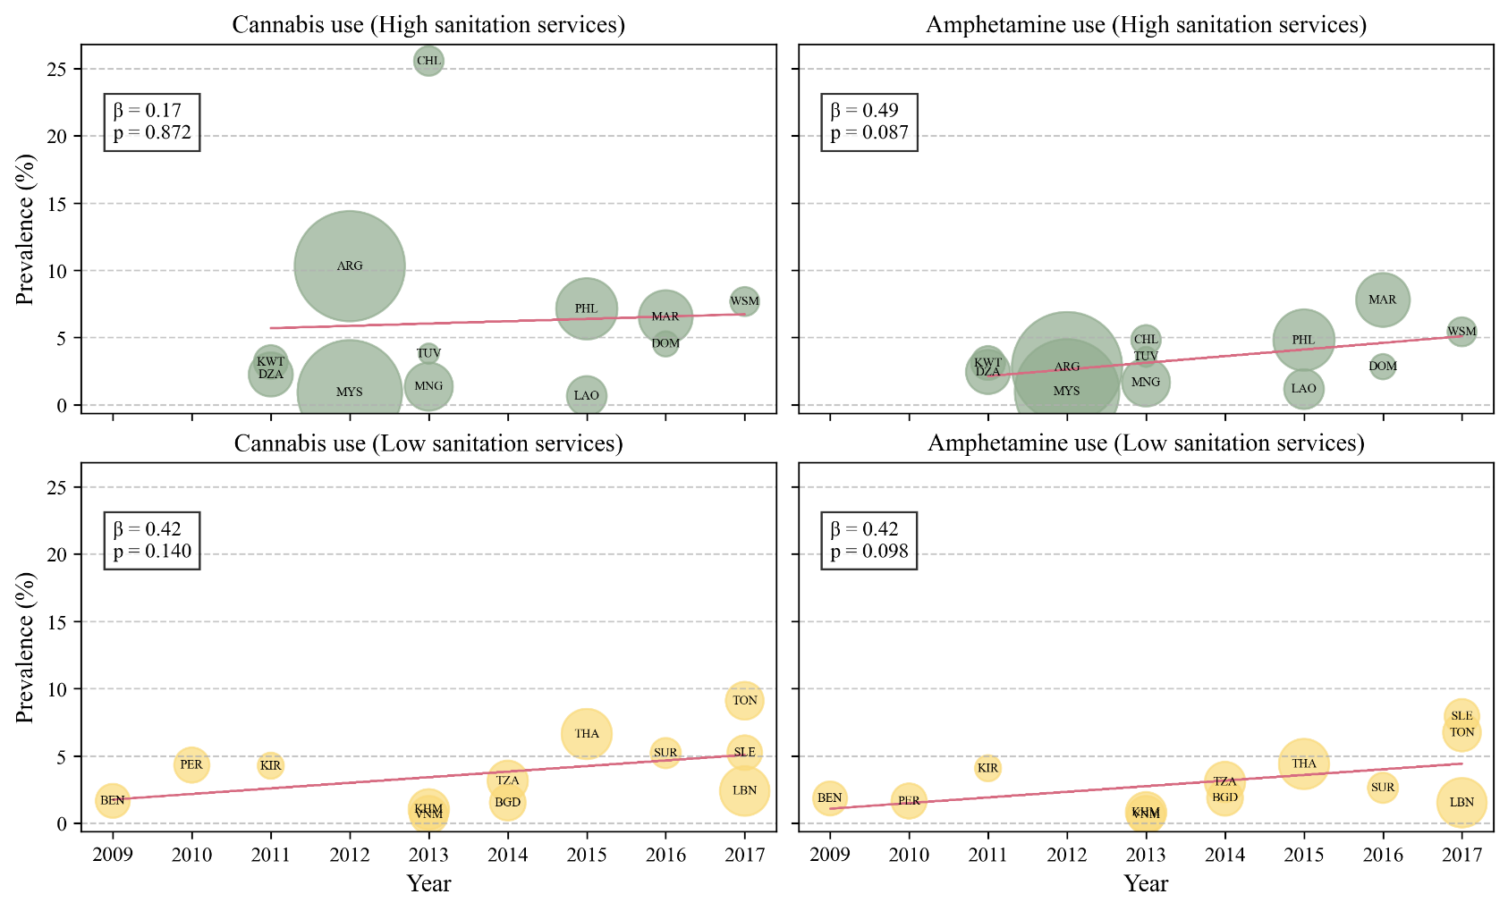
Figure S3. Prevalence of cannabis and amphetamine use by sanitation service levels over time

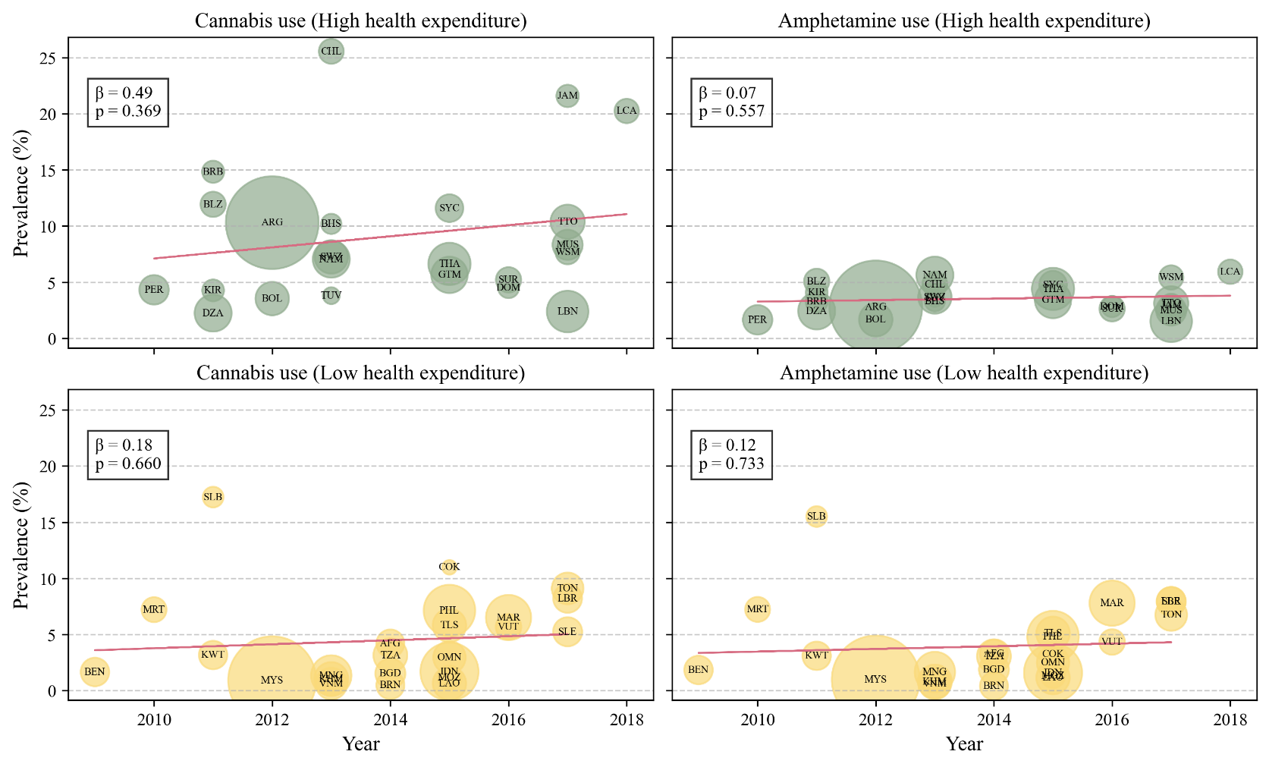
Figure S4. Prevalence of cannabis and amphetamine use by health expenditure levels over time

Table S1. Baseline characteristics of the study
Country | Survey year | Sample size | Boys (%) | Response rate (%)ª | Country income level^{b} | Homicides  rate^{c} | Sanitation services^{d} | Health expenditure^{e}
Overall |  | 220,362 | 50.04 | 92.68
African Region (AFR)
Algeria | 2011 | 4,532 | 51.89 | 88.11 | UMIC | 1.3 (0.7 to 2.2) | 62.26 | 9.03
Benin | 2009 | 2,690 | 33.06 | 95.84 | LIC | 6.6 (3.2 to 12.1) | 1.77 | 5.11
Eswatini | 2013 | 3,680 | 51.24 | 93.72 | LMIC | 20.6 (9.9 to 35.9) | N/A | 11.66
Liberia | 2017 | 2,744 | 48.17 | 79.45 | LIC | 10.0 (4.9 to 18.0) | N/A | 3.96
Mauritania | 2010 | 2,063 | 45.51 | 86.96 | LMIC | 12.0 (5.7 to 22.1) | N/A | 4.22
Mauritius | 2011 | 2,168 | 51.44 | 94.37 | UMIC | 3.6 (2.7 to 4.6) | N/A | 7.36
Mauritius | 2017 | 3,012 | 53.49 | 93.29 | UMIC | 3.3 (2.4 to 4.4) | N/A | 10.2
Mozambique | 2015 | 1,918 | 47.07 | 92.81 | LIC | 4.1 (2.1 to 7.2) | N/A | 5.55
Namibia | 2013 | 4,531 | 53.10 | 89.72 | UMIC | 19.0 (9.5 to 31.9) | N/A | 10.91
Seychelles | 2015 | 2,540 | 49.61 | 89.45 | HIC | 13.4 (8.1 to 21.0) | N/A | 10.03
Sierra Leone | 2017 | 2,798 | 48.36 | 71.91 | LIC | 8.0 (3.8 to 14.8) | 12.06 | 3.63
United Republic of Tanzania | 2014 | 3,793 | 50.91 | 91.14 | LIC | 8.8 (4.7 to 15.1) | 19.94 | 6.94
Region of the Americas (AMR)
Argentina | 2012 | 28,368 | 51.71 | 94.08 | UMIC | 6.0 (5.0 to 7.0) | 45.82 | 16.66
Bahamas | 2013 | 1,357 | 52.04 | 92.63 | HIC | 32.2 (26.3 to 39.2) | N/A | 14.02
Barbados | 2011 | 1,629 | 50.57 | 95.09 | HIC | 11.7 (9.0 to 15.0) | N/A | 10.61
Belize | 2011 | 2,112 | 51.82 | 88.78 | LMIC | 36.8 (30.6 to 43.7) | N/A | 12.7
Bolivia | 2012 | 3,696 | 49.02 | 92.94 | LMIC | 12.2 (6.8 to 19.3) | N/A | 8.31
Chile | 2013 | 2,049 | 50.35 | 95.12 | HIC | 4.1 (3.5 to 4.7) | 88.93 | 15.41
Dominican Republic | 2016 | 1,481 | 50.36 | 93.92 | UMIC | 17.9 (11.1 to 27.0) | 45.76 | 15.7
Guatemala | 2015 | 4,374 | 47.56 | 91.79 | LMIC | 28.2 (23.2 to 33.9) | N/A | 18.11
Jamaica | 2017 | 1,667 | 50.85 | 84.88 | UMIC | 55.4 (38.9 to 75.9) | N/A | 13.95
Peru | 2010 | 2,882 | 49.41 | 97.09 | UMIC | 7.1 (5.0 to 9.8) | 29.69 | 11.68
Saint Lucia | 2018 | 1,970 | 52.03 | 90.15 | UMIC | 20.4 (15.2 to 26.6) | N/A | 8.53
Suriname | 2016 | 2,126 | 50.91 | 94.73 | UMIC | 7.4 (4.4 to 11.6) | 26.47 | 13.71
Trinidad and Tobago | 2011 | 2,811 | 50.78 | 94.09 | HIC | 37.8 (32.9 to 43.1) | N/A | 8.01
Trinidad and Tobago | 2017 | 3,869 | 51.85 | 93.00 | HIC | 36.5 (25.7 to 49.9) | N/A | 11.17
Eastern Mediterranean Region (EMR)
Afghanistan | 2014 | 2,579 | 44.67 | 90.58 | LIC | 8.6 (4.7 to 14.8) | N/A | 1.86
Kuwait | 2011 | 2,672 | 47.74 | 85.70 | HIC | 1.9 (1.4 to 2.4) | 100.00 | 5.05
Lebanon | 2011 | 2,286 | 53.32 | 95.41 | UMIC | 3.9 (2.0 to 7.0) | 22.30 | 12.4
Lebanon | 2017 | 5,708 | 53.19 | 90.31 | UMIC | 4.1 (3.0 to 5.9) | 25.27 | 12.03
Morocco | 2016 | 6,745 | 46.21 | 82.88 | LMIC | 1.8 (0.9 to 3.3) | 58.35 | 7.02
European Region (EUR)
Oman | 2015 | 3,468 | 50.17 | 94.26 | HIC | 0.7 (0.3 to 1.3) | N/A | 8.26
South–East Asian Region (SEAR)
Bangladesh | 2014 | 2,989 | 34.77 | 97.56 | LMIC | 3.1 (1.9 to 4.9) | 21.51 | 3.59
Indonesia | 2015 | 11,142 | 51.11 | 95.76 | LMIC | 4.6 (3.4 to 6.1) | N/A | 6.63
Thailand | 2015 | 5,894 | 52.91 | 94.62 | UMIC | 5.2 (3.5 to 7.4) | 24.26 | 12.53
Timor-Leste | 2015 | 3,704 | 49.32 | 87.47 | LMIC | 4.1 (1.4 to 7.5) | N/A | 4.51
Western Pacific Region (WPR)
Brunei Darussalam | 2014 | 2,599 | 49.91 | 97.23 | HIC | 0.8 (0.5 to 1.3) | N/A | 5.2
Cambodia | 2013 | 3,806 | 47.67 | 96.16 | LIC | 2.4 (1.3 to 4.2) | 23.39 | 6.64
Cook Islands | 2011 | 1,274 | 49.53 | 93.80 | N/A | N/A | N/A | 8.82
Cook Islands | 2015 | 701 | 51.37 | 94.15 | N/A | N/A | N/A | 7.18
Kiribati | 2011 | 1,582 | 52.79 | 95.83 | LMIC | 5.5 (2.6 to 10.0) | 22.41 | 9.29
Lao People's Democratic Republic | 2015 | 3,683 | 46.71 | 98.78 | LMIC | 7.0 (3.2 to 12.6) | 53.91 | 3.35
Malaysia | 2012 | 25,507 | 49.83 | 97.56 | UMIC | 2.8 (1.8 to 4.2) | 79.62 | 6.54
Mongolia | 2010 | 5,238 | 52.49 | 92.42 | LMIC | 10.1 (6.7 to 14.7) | 53.50 | 7.74
Mongolia | 2013 | 5,393 | 51.72 | 94.05 | LMIC | 8.4 (5.1 to 13.1) | 56.93 | 7.11
Philippines | 2015 | 8,761 | 50.55 | 96.40 | LMIC | 15.3 (13.0 to 18.1) | 55.76 | 8.14
Samoa | 2011 | 2,418 | 51.60 | 72.54 | LMIC | 3.8 (1.8 to 7.1) | 49.12 | 10.89
Samoa | 2017 | 1,955 | 52.19 | 90.28 | LMIC | 3.2 (1.4 to 5.9) | 45.71 | 12.7
Solomon Islands | 2011 | 1,421 | 45.79 | 84.24 | LMIC | 4.7 (2.5 to 8.0) | N/A | 7.43
Tonga | 2010 | 2,211 | 48.36 | 92.40 | LMIC | 3.8 (1.9 to 6.9) | 37.04 | 10.07
Tonga | 2017 | 3,333 | 49.28 | 88.54 | UMIC | 3.6 (1.7 to 6.7) | 33.85 | 7.32
Tuvalu | 2013 | 943 | 51.64 | 93.53 | UMIC | N/A | 41.90 | 12.36
Vanuatu | 2016 | 2,159 | 50.40 | 85.13 | LMIC | 2.4 (1.1 to 4.6) | N/A | 3.66
Viet Nam | 2013 | 3,331 | 53.13 | 98.86 | LMIC | 1.8 (1.0 to 3.1) | 40.88 | 8.16
Abbreviations: HIC, high-income countries; LIC, low-income countries; LMIC, lower-middle income countries; N/A, Not available; UMIC, upper-middle-income countries.
ª Response rate is for the questions included in the study. Data are for participants aged 12–15 years.
^{b} Country income level was categorized by World Bank income category.
^{c} Estimates of rates per 100,000 population (%): Data sourced from the World Health Organization (WHO). Indicator details are available at https://www.who.int/data/gho/data/indicators/indicator-details/GHO/estimates-of-rates-of-homicides-per-100-000-population [Accessed on July, 2024].
^{d} Population using safely managed sanitation services (%): Data sourced from WHO. Indicator details are available at https://www.who.int/data/gho/data/indicators/indicator-details/GHO/population-using-safely-managed-sanitation-services-(-) [Accessed July 2024].
^{e} Domestic general government health expenditure (GGHE-D) as a percentage of general government expenditure (GGE) (%): Data sourced from WHO. Indicator details are available at https://www.who.int/data/gho/data/indicators/indicator-details/GHO/domestic-general-government-health-expenditure-(gghe-d)-as-percentage-of-general-government-expenditure-(gge) [Accessed July 2024].

Table S2. Prevalence of combined categories of cannabis use and amphetamine/methamphetamine use among adolescents in 47 countries based on data obtained from the GSHS
Weighted rate (%) | Cannabis use |  |  | Amphetamine or methamphetamine use
Weighted rate (%) | Total | Boys | Girls | Total | Boys | Girls
Overall (number of countries) | 7.02 (6.16 to 7.89) | 9.20 (8.05 to 10.36) | 4.20 (3.68 to 4.72) | 4.05 (3.51 to 4.60) | 5.14 (4.45 to 5.84) | 2.34 (2.00 to 2.69)
World Bank income category
LIC (7) | 3.46 (2.01 to 4.91) | 3.61 (2.18 to 5.05) | 2.58 (1.40 to 3.76) | 3.67 (2.06 to 5.28) | 3.43 (2.02 to 4.85) | 3.16 (1.60 to 4.72)
LMIC (18) | 6.90 (5.43 to 8.36) | 8.85 (6.90 to 10.81) | 4.22 (3.34 to 5.10) | 5.72 (4.47 to 6.97) | 6.78 (5.24 to 8.32) | 3.83 (2.96 to 4.70)
UMIC (14) | 7.07 (5.11 to 9.02) | 10.12 (7.31 to 12.92) | 3.87 (2.86 to 4.89) | 3.12 (2.38 to 3.85) | 4.81 (3.69 to 5.92) | 1.32 (0.93 to 1.72)
HIC (8) | 9.45 (6.06 to 12.84) | 12.36 (7.62 to 17.10) | 5.92 (4.21 to 7.62) | 3.03 (1.90 to 4.16) | 4.27 (2.64 to 5.90) | 1.52 (0.90 to 2.14)
P-value (group comparison) | 0.385 | 0.202 | 0.578 | 0.310 | 0.415 | 0.156
Homicide rateª
High (23) | 7.34 (5.94 to 8.74) | 9.37 (7.55 to 11.19) | 4.93 (3.96 to 5.89) | 3.71 (3.07 to 4.36) | 4.49 (3.69 to 5.29) | 2.56 (2.00 to 3.13)
Low (24) | 6.54 (5.36 to 7.71) | 8.79 (7.19 to 10.38) | 3.43 (2.77 to 4.10) | 4.50 (3.68 to 5.33) | 5.85 (4.74 to 6.96) | 2.24 (1.77 to 2.72)
P-value (group comparison) | 0.391 | 0.639 | 0.012 | 0.139 | 0.051 | 0.395
Sanitation services^{b}
High (12) | 7.76 (5.85 to 9.68) | 10.02 (7.47 to 12.57) | 4.49 (3.43 to 5.54) | 5.36 (3.99 to 6.73) | 6.85 (5.08 to 8.62) | 2.97 (2.14 to 3.81)
Low (13) | 3.96 (2.80 to 5.11) | 5.44 (3.86 to 7.03) | 2.21 (1.52 to 2.89) | 3.27 (2.35 to 4.19) | 4.34 (3.13 to 5.56) | 1.83 (1.25 to 2.41)
P-value (group comparison) | 0.001 | 0.003 | <0.001 | 0.013 | 0.022 | 0.028
Health expenditure^{c}
High (24) | 9.82 (7.95 to 11.69) | 13.02 (10.63 to 15.41) | 6.48 (5.20 to 7.76) | 4.58 (3.66 to 5.49) | 6.15 (4.95 to 7.35) | 2.63 (2.00 to 3.26)
Low (23) | 4.29 (3.53 to 5.04) | 5.52 (4.51 to 6.54) | 2.27 (1.83 to 2.71) | 3.56 (2.91 to 4.22) | 4.23 (3.42 to 5.03) | 2.10 (1.69 to 2.52)
P-value (group comparison) | <0.001 | <0.001 | <0.001 | 0.076 | 0.009 | 0.169
Abbreviations: GSHS, Global School-based Student Health Survey; HIC, high-income countries; LIC, low-income countries; LMIC, lower-middle income countries; UMIC, upper-middle-income countries.
ª Estimates of rates per 100,000 population (%)
^{b} Population using safely managed sanitation services (%)
^{c} Domestic general government health expenditure (GGHE-D) as a percentage of general government expenditure (GGE) (%)
Numbers in bold indicate a significant difference (P < 0.05).
P-values for group comparisons were calculated using a t-test when there were two subgroups, and a one-way ANOVA when there were four subgroups.

Table S3. Prevalence of combined categories of drug initiation age among adolescents in 47 countries based on data obtained from the GSHS
Weighted rate (%) | Start before 11 years old |  |  | Start after 12 years old
Weighted rate (%) | Total | Boys | Girls | Total | Boys | Girls
Overall (number of countries) | 5.64 (4.96 to 6.31) | 7.26 (6.39 to 8.13) | 3.43 (3.02 to 3.84) | 5.90 (5.22 to 6.59) | 7.45 (6.59 to 8.31) | 3.75 (3.36 to 4.14)
World Bank income category
LIC (7) | 5.43 (3.17 to 7.69) | 5.28 (3.22 to 7.35) | 4.86 (2.78 to 6.93) | 2.73 (1.63 to 3.82) | 3.38 (1.79 to 4.97) | 1.70 (1.06 to 2.33)
LMIC (18) | 6.58 (5.20 to 7.95) | 8.08 (6.37 to 9.80) | 4.20 (3.39 to 5.01) | 6.38 (5.11 to 7.64) | 8.16 (6.53 to 9.79) | 4.01 (3.32 to 4.71)
UMIC (14) | 4.89 (3.82 to 5.96) | 7.10 (5.56 to 8.65) | 2.53 (1.94 to 3.12) | 5.73 (4.22 to 7.23) | 7.72 (5.71 to 9.73) | 3.62 (2.83 to 4.41)
HIC (8) | 5.28 (3.22 to 7.34) | 7.60 (4.60 to 10.60) | 2.82 (1.78 to 3.85) | 7.38 (4.87 to 9.89) | 8.79 (5.59 to 11.98) | 5.42 (3.86 to 6.98)
P-value (group comparison) | 0.779 | 0.769 | 0.412 | 0.312 | 0.301 | 0.312
Homicide rateª
High (23) | 5.99 (4.84 to 7.13) | 7.36 (5.96 to 8.75) | 4.34 (3.49 to 5.20) | 6.13 (4.93 to 7.34) | 7.74 (6.08 to 9.39) | 4.42 (3.53 to 5.31)
Low (24) | 5.14 (4.26 to 6.02) | 6.86 (5.67 to 8.05) | 2.47 (2.01 to 2.93) | 5.47 (4.62 to 6.32) | 7.06 (5.95 to 8.17) | 2.86 (2.41 to 3.32)
P-value (group comparison) | 0.249 | 0.593 | <0.001 | 0.380 | 0.504 | 0.002
Sanitation services^{b}
High (12) | 6.17 (4.65 to 7.70) | 7.92 (5.95 to 9.89) | 3.56 (2.66 to 4.47) | 6.41 (4.65 to 8.16) | 7.93 (5.68 to 10.17) | 3.79 (2.99 to 4.58)
Low (13) | 4.24 (3.10 to 5.38) | 5.45 (4.01 to 6.89) | 2.64 (1.94 to 3.33) | 3.86 (2.86 to 4.86) | 5.02 (3.72 to 6.33) | 2.34 (1.72 to 2.96)
P-value (group comparison) | 0.047 | 0.047 | 0.114 | 0.013 | 0.028 | 0.005
Health expenditure^{c}
High (24) | 6.61 (5.41 to 7.81) | 8.92 (7.33 to 10.52) | 4.02 (3.24 to 4.79) | 8.33 (6.72 to 9.94) | 10.57 (8.53 to 12.62) | 6.02 (4.90 to 7.15)
Low (23) | 4.60 (3.79 to 5.41) | 5.50 (4.49 to 6.50) | 2.88 (2.40 to 3.37) | 3.50 (2.90 to 4.10) | 4.58 (3.79 to 5.37) | 1.90 (1.55 to 2.25)
P-value (group comparison) | 0.007 | <0.001 | 0.015 | <0.001 | <0.001 | <0.001
Abbreviations: GSHS, Global School-based Student Health Survey; HIC, high-income countries; LIC, low-income countries; LMIC, lower-middle income countries; UMIC, upper-middle-income countries.
ª Estimates of rates per 100,000 population (%)
^{b} Population using safely managed sanitation services (%)
^{c} Domestic general government health expenditure (GGHE-D) as a percentage of general government expenditure (GGE) (%)
Numbers in bold indicate a significant difference (P < 0.05).
P-values for group comparisons were calculated using a t-test when there were two subgroups, and a one-way ANOVA when there were four subgroups.

